Quiz
Straight Ahead
Name:_________________________ Period:___ Date:________ Score:_____/40

- (4 pts) What is the difference between the NXT Video Trainer 2 program and the NXT-G Programming software? Should they ever be used at the same time? Why?
- (1 pt) Which palette in NXT-G does Video Trainer 2 use?

- (2 pts) What are “comments” in NXT-G and how should they be used?
- (2 pts) What are two ways to view a program in NXT-G which is larger than the programming window?
- (2 pts) What are two ways you can tell the difference between a “Move” and a “Motor” command in NXT-G?
- (2 pts) What are two ways to run a recently downloaded program on the NXT brick?
- (4 pts) List and describe each of the four ways the Duration of a Move block can be set.
- (2 pts) What is the difference between the Brake and Coast settings in a Move Block’s Next Action?
- (5 pts) If Ziffle’s Tribot travels 15cm with a duration setting of 500 degree, what duration setting should be used to have the Tribot travel 50cm?
- (4 pts) Describe how a tribot would behave with this program (include 4 facts):
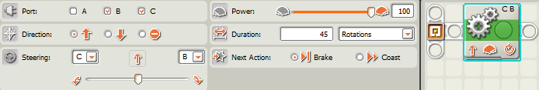
- (4 pts) Describe how a tribot would behave with this program (include 4 facts):
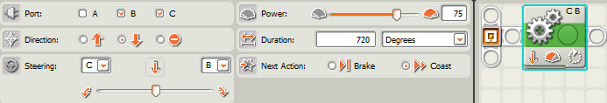
- (4 pts) Describe how a tribot would behave with this program (include 4 facts):
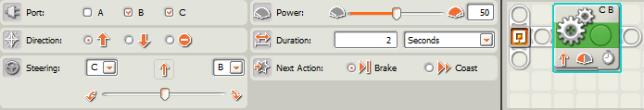
- (4 pts) Describe how a tribot would behave with this program:
